The Well Being of Children and the Question of Attachment
Student’s Name
Institutional Affiliation

The Well being of Children and the Question of Attachment
The most significant issue in the United States of America is children's well-being and the question of attachment. Nevada State is ranked as the leading geographic region with the ultimate rating of 95% regarding children's well-being and attachment. There is a significant relationship and the concept of how a child is attached to his/her close relatives, such as father, mother, and siblings (Land, 2017). Moreover, in 1975, the Nevada state government established a child department whose primary role was to investigate and make recommendations regarding children well being and how the attachment concept impacted their physical and emotional welfare. The department has indicated vital statistics up to 2013 (Land, 2017). Through a closer examination of child well-being portrait and the question of attachment in Nevada, we understand the change in statistical trends annually.
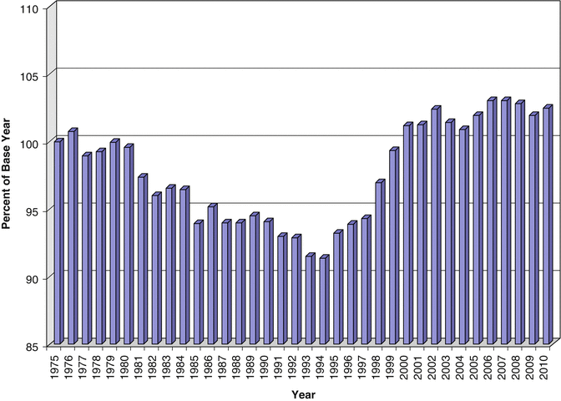
The above statistical portrait outlines the child well being and the question of attachment in Nevada for 38 years. From 1975 to the late 1970s, children's well-being had undergone distinct phases of deterioration as well as improvement. The base value rate in the 1970s was at 100, a value that started to decline from the early 1980s. The decline rate of child well-being in Nevada declined until 1994 with a value of 91.37. According to the Nevada child department, the central reason for the decrease in child well-being and lack of a concrete attachment between children and parents was based on economic reasons (Land, 2017). During the period mentioned above, Nevada was among the states in America that faced significant financial constraints. Parents did not have enough time with their children, and their bond grew weaker.
Additionally, Nevada's low economic status changed the family structure with disregard to the division of labor and specialization. Unlike in previous years, women who mainly spend time with children were forced to seek employment and satisfy their family's basic needs. This aspect resulted in the change of family structure hence low child care and attachment. Other factors that contributed to the low well-being of children and the development of poor attachments were the rise in crime rates, increased drug abuse as well as political instability (Land, 2017). The primary domain of well-being in children that were affected by the factors mentioned above between 1980-1994 was health.
The period between 1994-2013 is described as the medium-term where the children well-being value gradually increased to 102.49, that was the peak. The value of children's well-being and growth of family attachments in Nevada was as a result of various factors that included economic development of the region, political stability, as well as stabilization of the family structure. The American federal government intervened to solve Nevada's financial crisis (Twenge et al., 2018). Through the federal government's help, Nevada citizens were able to secure stable jobs with high incomes that enabled them to provide appropriate care for their children. Stabilization of family structure provided for the development of stronger attachment bonds between parents and their children.
The index value for children well being and the question of attachment of children in Nevada maintained the peak level from 2002. In 2011, the index value was 101.85, raised to 102.19 in 2012 and later to 102.90 in 2013. The excellent index value of children well being in Nevada can be attributed to a significant socio-economic recession that was recorded between 2008 and 2010. Moreover, the recession's impacts resulted in the decrease of child well-being value in 2009, where it was 103.22 in 2007 and 101.84 in 2009 (Twenge et al., 2018). Based on the data recorded from 2011, it is evident that the impacts of the great recession rarely affected the last four years.
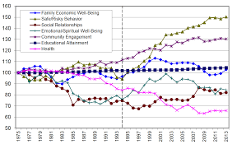
The statistical portrait above outlines the percentage change of seven children well being and the concept of attachment domains in Nevada from 1975 to 2013. The seven domains are the areas targeted for intervention, and they include family economic status, safe or risky behaviors impacting the well being of children and the concept of attachment, health, educational concept, community involvement, emotional as well as spiritual well being and social relationships (Twenge et al., 2018). The seven domains impacting the well-being of children and the question of attachment are dependent on the economic status of the federal government, as well as health insurance covers.
Based on the economic well-being of a child's family, all families in Nevada with children between the age of 1 to 17 can be ranked in various categories based on both parents' total income. Between 1990 and 1991, there was an economic recession in Nevada, a concept that decreased children's well-being (Orben et al., 2019). Another economic recession that negatively impacted children's well-being and how they were attached to their family members was between 2001 and 2002.
In 2013, the family income was recorded to be high by 11% compared to 1975 when the Nevada department of children made an economic status study of all citizens of the state. Moreover, there was a significant increase in the economic trend by 5% in 2013 compared to 1994. The general value of children well being and how they were attached to their families was high in 2013, 1994, and 1975 respectively (Orben et al., 2019). There was a significant relationship between the growth of economic trends and the well-being of children and the development of the family bond. Based on the aspect mentioned above, to improve children's general well-being and strengthen the family bond, the federal and state governments should focus on improving the economic status of parents (Orben et al., 2019). In most cases, when the parents are financially stable, they take good care of their children and create time for them, unlike in cases where the parents and suffering from poverty.
The income trend attained the peak value in 2000. The value recorded in 2000 was 22% higher than what was recorded in 1975. In 2013, Nevada's poverty rate was at 19.5%, which is slightly below 21.1% recorded in 1994. Due to the slight difference in the economic value recorded in 1994 and 2013, the well-being of children and how they are attached to their family members appear to be similar in both years (Xu et al., 2018). The economic recession may have been the central reason for the poverty rate recorded. On the other hand, Nevada's poverty level was at 15.6% in 2000, which is the lowest value ever be recorded in the states (Xu et al., 2018). Based on the aspect mentioned above, the Nevada department of children outlined that the general well-being of children was recorded highest in 2000 than any other year up to 2013.
Risky or safe behaviors and engagement of the community are the second and third target areas for intervention in improving children's well-being and the question of attachment. The risky behaviors that threaten the well-being of children were high by 30% from what was recorded in 2013 compared to the value recorded in 1975. Risky behaviors included crime victimization as well as drug and substance abuse. Among 1000 parents, 37.6% were involved in crime victimization activities in 1994. Moreover, the rate reduced to 12.3% in 2013 (Xu et al., 2018). Based on the above statistical data, it is evident that the low value of children well being and poor attachment with their family members was low in 1994 due to their parents being involved in criminal activities. When 37.6% of parents were involved in criminal activities, they lacked time for their children, and this aspect contributed to the development of poor bonds between parent and their children.
On the other hand, the community was engaged by 111.57 in 1994 as per children well being, and attachment to their families and other community members, and the value increased to 130.37 in 2017. Based on the statistics provided above, community engagement increased by 17% from 1994 to 2013. With the involvement of the community, some parents stopped feeling the burden of raising a child alone but as a community. The well-being of children gradually increased with the engagement of community members in knowing the well-being of a child. Moreover, community engagement resulted in the development of community attachment with children. In intervening in the well-being of children and the question of attachment concept, community plays a critical role (Bethell et al., 2017). The federal government and departments related to children's welfare in Nevada should focus on how the community can be engaged in being part of children raised by single parents. This aspect will increase the well-being of children and boost communal attachment.
The level of educational attainment of parents is another crucial domain that determines the well-being of children and the nature of the bond that will be developed. The rate of parents with higher education increased by 4.32% between 1975 and 2013 (Bethell et al., 2017). This aspect indicated that the more learned parents are, the more the knowledge of how to handle their children with care hence improving their well-being and creates a stronger parent-child attachment. Determining the educational level of parents will be an appropriate intervention in fostering the well-being of children since learned parents are more informed regarding children's care.
In conclusion, emotional and spiritual well-being, social relationship, and community health are the last three suitable domain interventions for the well-being of children and the attachment concept. Social relationships of Nevada residents from 1975 to 2013 increased by 27.75%. The increase in social relationships had a positive outcome regarding the well-being of children and also resulted in the creation of strong social attachment between children from various ethnicities (Bethell et al., 2017). The religious and emotional well-being of children is dependent on the religious and emotional status of their parents. The emotional well-being and spiritual status of parents in Nevada slightly decreased in 2013 compared to 1994 with 25% (Bethell et al., 2017). However, children had not become aware of their spiritual life as well as emotional status; hence this aspect did not impact their well-being or their attachment status to their parents. Health is a dynamic issue whose trend cannot be recorded in a given time but can be effectively evaluated through recording death rates resulting from all types of infections.

References
Bethell, C. D., Carle, A., Hudziak, J., Gombojav, N., Powers, K., Wade, R., & Braveman, P. (2017). Methods to assess adverse childhood experiences of children and families: toward approaches to promote child well-being in policy and practice. Academic pediatrics, 17(7), S51-S69.
Land, K. C. (2017). Child and youth well-being index report 2014. Durham, NC: Duke University Center for Child and Family Policy.
Orben, A., & Przybylski, A. K. (2019). The association between adolescent well-being and digital technology use. Nature Human Behaviour, 3(2), 173-182.
Twenge, J. M., & Campbell, W. K. (2018). Associations between screen time and lower psychological well-being among children and adolescents: Evidence from a population-based study. Preventive medicine reports, 12, 271-283.
Xu, G., Strathearn, L., Liu, B., & Bao, W. (2018). Prevalence of autism spectrum disorder among US children and adolescents, 2014-2016. Jama, 319(1), 81-82.

